

Lecture with Computer Exercises:
Modelling and Simulating Social Systems with MATLAB

Project Report

Opinion Formation

Lukas Böke Melanie Gut Anne Lüscher

Zürich
Dezember 2013
IMPORTANT

You MUST include the ETH declaration of originality here; it is available for download on the course website or at

http://www.ethz.ch/faculty/exams/plagiarism/index_EN;

It can be printed as pdf and should be filled out in handwriting.
Agreement for free-download

We hereby agree to make our source code of this project freely available for download from the web pages of the SOMS chair. Furthermore, we assure that all source code is written by ourselves and is not violating any copyright restrictions.

Lukas Böke Melanie Gut Anne Lüscher

Table of content

1. Abstract

A model for opinion convergence in a simple social system was developed and implemented as a simulation using MATLAB. The code was based on an existing model as suggested by Laguna, Abramson and Zanette.^{[1]} Additional parameters were introduced in order to make the model more realistic and dynamic. The parameters were then modified and simulations were conducted for each modification with the goal of finding the qualitative impact of each parameter on the system.

2. Individual contributions

The project was done in a collaborative manner by all three group members. In the beginning, ideas were collected and discussed in the group and the mathematical model was established. Later on, the work was roughly subdivided to the follow main responsibilities:
Lukas Böke: Implementation in MATLAB, writing of code
Anne Lüscher: Data analysis/results, writing of report
Melanie Gut: Presentation
However, we always counter-read each other’s work and were always informed, what the others were doing in order to keep an efficient workflow.

3. Introduction and Motivations

Opinion formation is a point of interest in various fields; especially in topics such as politics and public affairs it is of great importance. Therefore, it is not surprising that the realistic modelling of the dynamic, time-dependent process of opinion formation and development has become an interesting tool to predict trends. This is made possible by using simulation methods based on mathematical models, which make the necessary assumptions. But how can such a complex process be packed into a simple formula and then be converted into code, until it finally leads to a result? This was one of the questions we aspired to answer. Furthermore, we wanted to better understand how decisions are made and how peer influence can be included in a mathematical model. While studying related research papers we came across various approaches and noticed two things: Firstly, the models were often rather complex and thus not easy to implement. On the other hand, we found simpler ideas, which seemed to lead to valuable qualitative results none the less. We then found ourselves motivated to strike a balance between simplicity and complexity. In concrete terms: The idea came up to use a simple existing model and conduct some simulations in order to see how it works. In a second step, adding some factors would refine our approach and we would see, whether the system is influenced significantly by these factors and if so, what the differences are and how they can be explained.

4. Description of the Model

4.1 Basic Model

Our model is based on the approach used in [1]: We take N agents with a random opinion, which is represented by a number from [0, 1]. Now we repeatedly choose pairs of agents. Two of these agents interact, if the difference between their opinions is smaller than a previously defined threshold u. After one interaction between a pair of agents, the opinions of two agents a and b are described as follows:

x_{a} and x_{b} describe the opinion of agents a and b, respectively, as a function of time. The opinion at time t+1 differs from the opinion at time t if – and only if – an interaction between the agents takes place, which is the case if abs (x_{a}(t) - x_{b}(t)) < u is true. If this condition is met, the agents will adjust their opinions as much as the convergence parameter c allows. This parameter takes on values from [0,0.5] and controls, how much the opinions of two agents approach each other after an interaction. In the extreme case of c = 0.5, the agents’ opinions will meet in between the two initial values, and, consequently, converge completely, so that only one opinion prevails. If c=0, there will be no adaption at all, and both opinions remain unchanged. Summarily, c is of great importance to the model, as it has a substantial influence on the outcome of the simulation, as will be discussed later on. Therefore, choosing its value carefully is vital.

4.2 Refined Model 1: Introduction of parameter “Charisma”

We first added one new factor to our model, which we called “The Charisma” of an agent, for which we use the letter γ. This parameter, too, is assigned randomly. Our refined version blends into our basic model if two agents have the same γ. If two agents have different γ_{i}, meaning γ_{a} ≠ γ_{b}, the opinion of the agent with the smaller γ will change more than the opinion of the agent with the bigger γ.

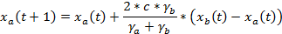
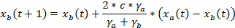

This was an important step towards a more realistic model, as the agent with greater charisma changes the opinion of his interaction partner more, than he adapts his own opinion. The exact value of how much the opinions change still depends on the convergence parameter, but is also determined by the two charisma values. Furthermore, a factor of two is included, which is required for the formula to be consistent with the basic model in the case where γ_{a} = γ_{b}.

4.3 Refined Model 2: Introduction of “Circle of Trust”

As soon as the charisma factor was included in the code, yet another parameter was added in order to account for the influence of familiarity between agents. The thought behind this was that peer influence depends on how well the agents know each other. It is intuitively clear that any agent will have a tendency to be more susceptible to a friend’s or family member’s influence than to a stranger’s. This problem was not easy to convert into a formula and we finally solved it using a physical approach by creating a two-dimensional “trust space”.
In the new model, every agent is assigned a random point in [0, 1]x[0, 1]. The (mathematical) distance between two agents in this square corresponds to how well two agents know each other. Thus, we can define “circles of trust” around one agent with different radiuses, where the change of opinion is now dependent on “how far away” the two agents are from each other within the social system. We assume that the closer two agents are in space the better they know each other, which then determines the convergence of their opinions.

5. Implementation

The implementation in MATLAB is quite simple and straightforward: For the opinions of the agents we have a matrix M, where the rows correspond to the opinions of one agent at different times, and the columns correspond to all opinions of all agents at a given time t. For the position and the charisma of an agent we again use a matrix/vector, with the rows corresponding to one agent. In our model, position and charisma are constants. To randomly choose the pairs of interacting agents, we first shuffle the rows of all matrices/vectors we use, such that the i-th row in every matrix/vector in our simulation always corresponds to the same agent. After that we split the matrices in two halves. Now the i-th agent in the first half is paired with the i-th agent in the second half. We then check if the differences of two agents opinions are smaller than our threshold u an in what circle of each other the agents are. We then use the formulas above to compute the new opinions of the agents.

6. Simulation Results and Discussion

6.1 Conducting the Simulations

In the different runs we tried to determine the impact of each factor on the outcome of the simulation. The plots were then analysed with focus on the following aspects:
1. How quickly (after how many iterations) is the equilibrium reached?
2. How many opinions prevail? Is there a complete convergence? Is there any cluster formation?
3. Are the results consistent with our predictions?
4. Are the outcomes both reproducible and reliable?

6.2 Influence of the Number of Agents

Unfortunately, the number of agents had to be strongly restricted due to workspace problems. The simulation was run with 100, 500 and 1000 agents. With only 100 agents, the results were not very reliable. The distributions often seemed to be random and the results were not reproducible. This is obviously due to the randomly assigned opinions and values for γ. As could also be seen in the plots, the distribution of the initial opinions between 0 and 1 is sometimes more uniform and sometimes less so. With growing number of agents, the distribution becomes more reliable and so do the results. It became clear, that 500 agents are a good compromise. The initial opinions are equally enough distributed, but the time for a single calculation is still within a reasonable range.
This is illustrated by Figs 1.-4. In Fig.1 the simulation was conducted with 1000 agents. The assignment of initial opinions is perfectly uniform and in the end only one opinion prevails (converges to 0.5). With 500 agents (Fig.2) the simulation still looks similar, so does the initial distribution of opinions. This is different if just 100 agents are used. As a consequence of the small number of agents, there is a statistically induced “pre-clustering" of opinions when the initial values are assigned. 100 agents are simply not enough to reach an initial situation, where the random opinion values are regularly distributed. From Fig. 3, Fig.4 it can be deducted that if those pre-clusters are in the peripheral opinion space (either close to 0 or to 1), two main opinions will prevail, while complete convergence can be observed if the pre-clusters are closer to 0.5. However, running the programme with a smaller amount of agents still proved itself to be an important tool, as that way the opinion behaviour of single agents is perfectly traceable.
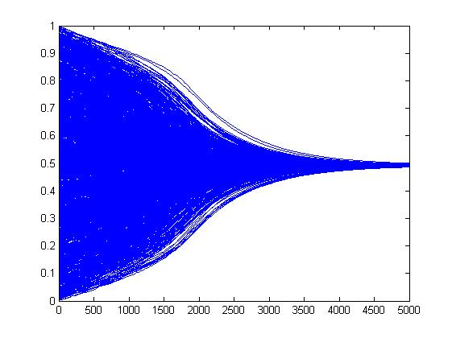
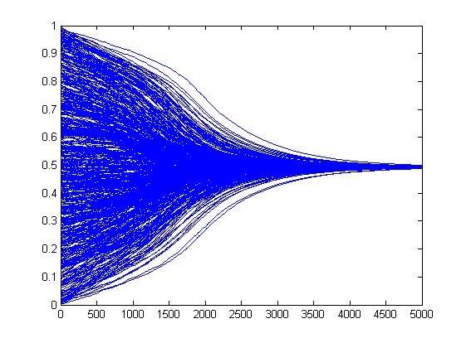

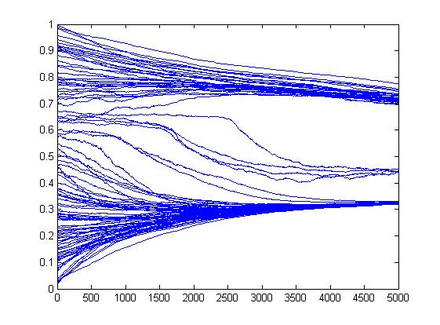
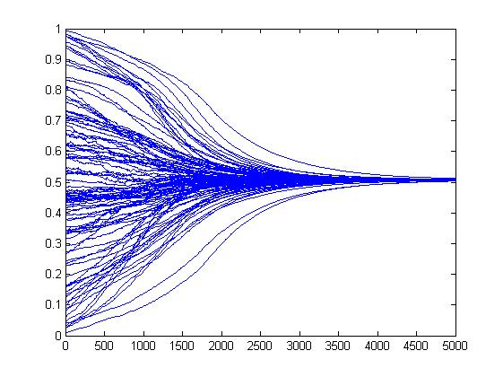

6.3 Influence of convergence parameter c

The convergence parameter is chosen arbitrarily, which may be one weakness of our model. It’s only purpose is controlling how quickly two opinions merge - in other terms, by how much two agents approach their opinions after an interaction. This obviously influences, after how much time the equilibrium is reached. This becomes interesting, if the time (or the number of interactions) is set to a certain value. Depending on c, the number of opinions at that point will be very different. For large c, meaning values close to 0.5, interesting anomalies occur. As the convergence happens so quickly, sometimes several opinions prevail. There is one main opinion plus a few minorities. Our explanation is that there is a stochastic chance that some agents will within the first few interactions only meet agents, with which the threshold u is not reached or from whose opinion they do not differ much. Consequently, they keep their opinion or only change it slightly. Because of the large value of c, the main part of convergence has already happened after very few interactions, and at that point, there are no agents left within the threshold. This was already found by Laguna, Abramson and Zanette in their version of the model. Our assumption is supported by the fact, that minorities become less frequent if either the threshold is made larger or c made smaller.

6.4 Influence of threshold u

The threshold’s value is surprisingly influential. While the convergence parameter has only an impact if a rather extreme value is chosen, the threshold changes the result already with moderate modifications.

6.5 Influence of γ
To be analysed.

6.6 Influence of circle of trust

To be analysed.

Summary and Outlook

The formula given in our reference^{[1]} was translated into code successfully, so that we could reproduce the results with our programme. We came to the same qualitative conclusions about the influence of the threshold u and the convergence parameter c.
The final source code could be a valuable basis for further modifications of the model. The parameters could easily be connected. If there were to be a scientifically proven correlation between charisma and, for instance, the extremeness of an agent’s opinion, this could be incorporated into the model.
A very obvious addition would be making the interaction probability a function of the distance between two agents.
Another modification could be to not have a normal distribution of the initial opinions, but a different approach.

References
[1] M.F.Laguna, Guillermo Abramson, Damiàn H. Zanette: “Minorities in a Model for Opinion Formation”

